MEDIA RELEASE PERTH, 4/09/2018 - [FOR IMMEDIATE RELEASE]
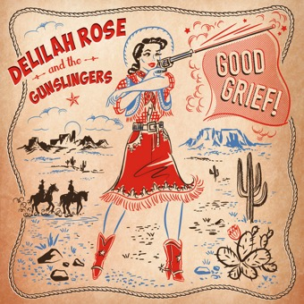
Artwork by Red Pepper Graphics

Good Grief! What’s next from Delilah Rose & the Gunslingers?!

Perth five-piece Delilah Rose & the Gunslingers celebrate the release of their second EP Good Grief! Saturday 13th October at Clancy’s Fremantle with support from Michael Savage and Tom Fisher & the Layabouts.

Having met with grief head on after her dad passed suddenly in 2014, Delilah faced and embraced it. The four songs on Good Grief! are the result and a love letter to grief itself. Delilah worked with the production team of Elliot Smith and Noah Shilkin at Sundown Studios Fremantle and successfully crowdfunded the project earlier in the year.

Fronted by Delilah Rose on vocals and guitar, the Gunslingers play an often rowdy, distinctly Western Australian brand of alt-country folkabilly. Delilah channels her wheatbelt upbringing in her songs - her lyrics conjure the landscape and characters of our own Wild West with an unflappability, a plain-spoken emotional honesty and a razor-sharp sense of humour.

“Good honest Sunday afternoon alt twang with a sprinkle of rock n roll. Music to cut up the rug to or just casually lean into the bar and your beverage. Upbeat rhythms, minor chords and lyrics that will tease a smile out of your skeptical heart.” Jane Hebiton; RTRfm presenter

The first single from the EP, Big Moon, is "a total bop-a-long tune with so much spunk! Thanks for putting a smile on this lil lady's face." Nkechi Anele, Roots and All, Triple J

For media bookings and opportunities contact:
Delilah Walsh – 0408037896
delilahrosemusic@gmail.com

